SKETCHING HISTORIC TASMANIA
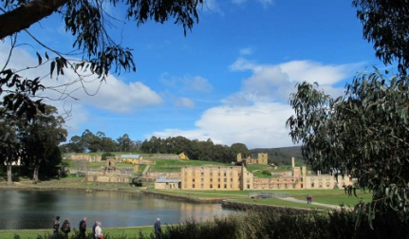
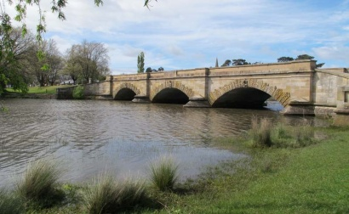
30 January – 5 February 2016
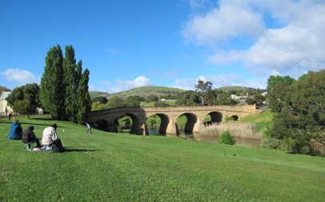

Day 1 Arrive Hobart. Meet and greet before dinner.

Day 2 Visit Salamanca Markets near the historic sandstone warehouses near Hobart’s waterfront. Experience the sights and sounds where Tasmania’s arts and crafts are showcased and the local foods are in abundance.
Afternoon: There will be a leisurely stroll around Barrack Point which is one of Hobart’s oldest and most historic areas. We will sketch some of original free settlers cottages.

Day 3 This morning we will travel to the heritage village of Ross with its sandstone architecture and tree lined streets which offer excellent sketching opportunities. We will be sketching the Ross Bridge, famous for its engraved Celtic motifs.
Afternoon: We travel to Oatlands, an historic Georgian village and one of Tasmania’s oldest settlements. It was established in 1821 as a military base for the control of convicts. It has the largest collection of sandstone buildings in Australia and affords excellent sketching opportunities.

Day 4 Today is spent in Port Arthur which was established as a harsh convict settlement in 1830. There will be a guided tour of the settlement and a harbour cruise. The many interesting convict buildings provide excellent sketching opportunities. See the original penitentiary, the convict Cathedral and the lovely grounds and gardens.
Afternoon: There will be time for more exploration and sketching before returning to Hobart.

Day 5 Visit the historic heritage town of Richmond where you can sketch the oldest bridge in Australia. This convict built sandstone bridge was built in 1823. Wander around the town and see many examples of early colonial architecture.
Afternoon: A visit to the famous Richmond gaol, court house and original convict barracks are a must.
Afternoon: A visit to the summit of Mt. Wellington where you will experience the 360 degree view of Hobart city and the Derwent River.

Day 6 We sketch some of Hobart’s historical buildings and go back into a bygone era. The subjects will include Salamanca Place with its fine Georgian buildings.
Afternoon: We will visit the Allport Library and Museum of Fne Arts, where the history of Hobart’s earliest inhabitants can be seen. View the museum’s heritage collection of colonial artefacts and learn a little about Hobart’s history.

Day 7 Flying home
$950.00 per person
Fully escorted tour including mini bus

