PEN & WASH – SKETCHING WATER & SKY

ONE DAY WORKSHOP WEA SATURDAY 16 JULY 2016
10am – 4pm

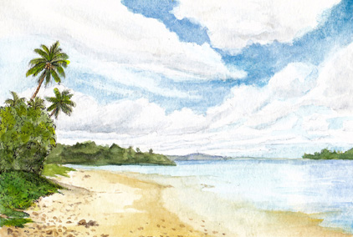

Capture the many moods of water, including ripples, waves and reflections. Create atmosphere in your skies from clear, cloudy and rainy to sunrises and sunsets. Learn to sketch with a black waterproof pen and watercolour wash. Comprehensive class demonstrations will include elements of sketching and watercolour techniques. Learn to sketch from photographs and on location. Individual tuition will be given for all skill levels. Ensure you have a Materials List from WEA.

