BOTANICAL ART & TRAVEL SKETCHING
with Leonie Norton

10 -17 May 2015

Saturday 9 May Stay Raffles Hotel, opposite Nadi Airport. Dinner with the group (own expense)
Sunday 10 May Breakfast in hotel, excurison to The Garden of the Sleeping Giant.
Lunch at Raffles (own expense)
Afternoon flight to Savusavu.

Monday 11 May
08.00 am Breakfast 8.00am each morming
09.00-12.00 Botanical Art workshop
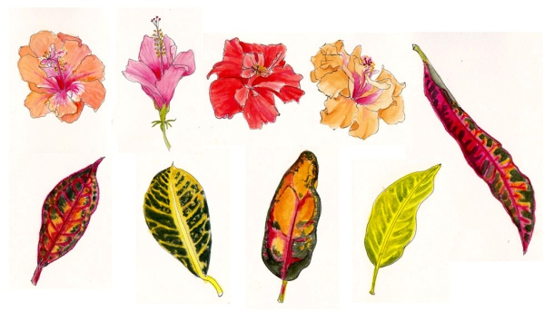
10.30 am Morning tea
12.30 pm Lunch
01.30 pm Pen & Wash Workshop, sketching around resort
07.00 pm Dinner 7.00pm each evening

Tuesday 12 May
09.00 -12.00 Botanical Art Workshop
10.30 am Morning tea
12.30 pm Lunch
Afternoon Visit to Savusavu, local market, hot springs and shops. Sketching in town.

Wednesday 13 May
09.00-12.00 Botanical Art Workshop
10.30 am Morning tea
12.30 pm BBQ lunch at Wina beach with sketching, relaxing – free afternoon

Thursday 14 May
09.00-12.00 Botanical Art Workshop
10.30 am Morning tea
12.30 pm Lunch
01.30 pm Rainforest trek with sketching
Friday 15 May
09.00-12.00 Botanical Art Workshop
10.30 am Morning tea
12.30 pm Lunch
Afternoon Waterfall excursion (leisurely walk) with sketching
Saturday 16 May
09.00-12.00 Botanical Art Workshop
10.30 am Morning tea
12.30 pm Lunch
01.30 pm Relaxing. Optional outings to beach or locations along the coast with sketching

Sunday 17 May
Return to Nadi and flights home

The afternoon programme may change depending on the weather and the interests of the group

