Siem Reap, Cambodia Itinerary
with Leonie Norton - 27 June – 6 July 2016

Day 1. Monday 27 - Arrival and Welcome dinner
Arrival at Siem Reap international airport and transfer to your accommodation. Welcome dinner and cocktails at 7pm at the hotel restaurant.

Day 2 – Tuesday 28 - City Orientation, Painting & Artisans of Angkor workshop
8.30am. After breakfast we leave for a city orientation, then stop for some sketching close to town. In the afternoon we enjoy an Artisan workshop tour and refreshments, about an hour. Return to the hotel by 1 - 2 pm . Afternoon sketching workshop covering various techniques, then leisure time. Evening at leisure.
Day 3 – Wednesday 29 – Angkor Wat
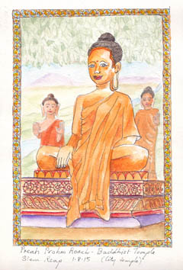
7.30am. Early breakfast to visit Angkor Wat with local guide. Stop to pick up entry pass then on to Angkor Wat for tour with our Temple guide and sketching. Lunch/coffee break then back to hotel. Sketching workshop/finishing off sketches with tuition. Evening at leisure.
Day 4 – Ta Prohm Temples Adventure
8.00am. After breakfast we head out with sketchbooks to one of the great atmospheric temples, Ta Prohm, where we stop for some sketching then explore this beautiful little temple with our guide, finishing about 12.30. Evening at leisure.

Day 5 – Ancient city of Angkor Thom
8.00am. The best time of day to explore the ancient city of Angkor Thom with our guide and explore the famous Bayon and its many faces along with other impressive temple ruins close by. We take the tuk tuk and visit the North Gate entry for some sketching by the moat and old city wall before heading back to our accommodation around 1pm. Evening at leisure.
Day 6 - Free Day
Today is a free day to shop, explore or just relax. Maybe do some temple sketching or take a tour, have a massage by the pool or visit the markets.

Day 7 - Kompong Phlluk and the Great Lake Tonle Sap
7.30am. Today is a big day. After breakfast we travel to Kompong Plluk, ‘the Stilted Village’ which is located on the Great Lake Tonle Sap. We stop to explore an extensive and varied local market before boarding a boat that takes us to the Flooded Forest, past rice fields to Kompong Phlluk, a truly amazing and unique site. We have a Khymer style lunch in a local house and stay for some sketching before returning around 4pm. Evening at leisure.
Day 7 - Sketching &Free Afternoon
Sketching in the morning, location to be advised. Free afternoon.

Day 8 – Village Sketching and Local Artist Studio and gallery
9am. A relaxing morning sketching at a picturesque local village. Break for morning refreshments before heading off to visit a local artist’s studio and gallery. There is a comprehensive gift shop attached to the gallery. Return to the hotel in time for a late lunch and swim.

6.30pm. If you would like to join Leonie and Glen, we will take you to the Night Market areas in downtown Siem Reap and along some of the hidden alleyways and back streets.
Day 9 – Free Day & Farewell Dinner
Today is a free day to shop, explore or just relax.
7pm. We all meet up this evening for our Farewell Dinner and drinks in the hotel restaurant.

Day 10 – Transfer to your flights
Transfer to the International Airport for your flights.

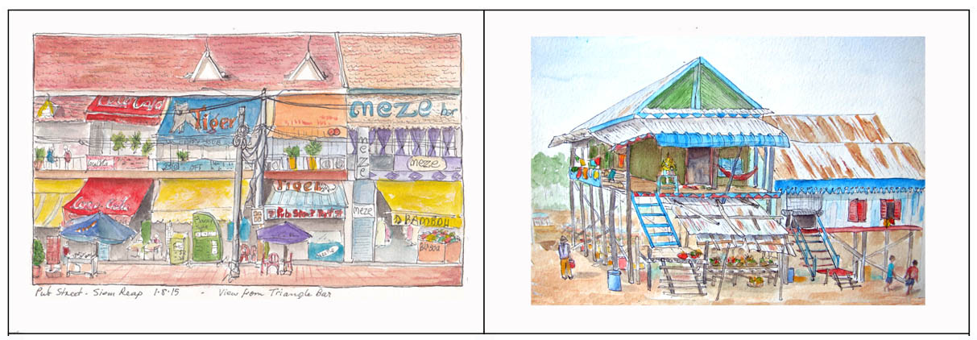

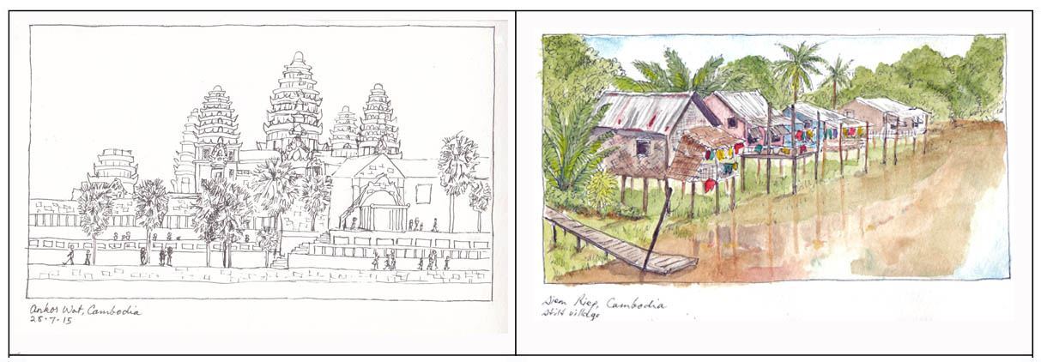

Some sketches in Siem Reap

Enquiries and Bookings: www.paintingholidays.com.au
Contact Glen: glen@paintingholidays.com.au Phone: 0437 126 360
Sketching Information: www.holidaysketching.com.au
Contact Leonie: leonienorton@iprimus.com.au

